**Assignment – 3**

**Financial Analytics**

**Title : Analyzing competitive advantage in real companies**

**CONTENT**

* **Introduction**
* **Background**
* **Competitive advantage**
* **Financial performance evaluation**
* **Comparative analysis**
* **Assessment of sustainability**
* **Conclusion**

In this task I am analysing the competitive advantage of two real companies operating in different industries. One company from technology sector i.e. **TECH MAHINDRA** and another from the consumer goods sector i.e. **DABUR INDIA LIMITED**.

* **Introduction**
* **Company from technology sector :** **TECH MAHINDRA**

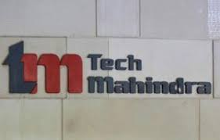

**Tech Mahindra** is an Indian multinational information technology services and consulting company. Part of the [Mahindra Group](https://en.wikipedia.org/wiki/Mahindra_Group), the company is headquartered in [Pune](https://en.wikipedia.org/wiki/Pune) and has its registered office in [Mumbai](https://en.wikipedia.org/wiki/Mumbai). Tech Mahindra has over 146,000 employees across 90 countries. The company was ranked #5 in [India's IT firms](https://en.wikipedia.org/wiki/List_of_Indian_IT_companies) and overall No. 47 on [Fortune India 500](https://en.wikipedia.org/wiki/Fortune_India_500) list for 2019.

On 25 June 2013, Tech Mahindra announced the completion of a [merger](https://en.wikipedia.org/wiki/Merger) with [Mahindra Satyam](https://en.wikipedia.org/wiki/Mahindra_Satyam). Tech Mahindra is one of the top [Big Tech (India)](https://en.wikipedia.org/wiki/Big_Tech_(India)) companies. Tech Mahindra has 1,262 active clients as of June 2022.

In March 2021, Tech Mahindra partnered with US-based business intelligence analytics company [thought spot](https://en.wikipedia.org/wiki/ThoughtSpot).

In October 2022 Tech Mahindra acquired 26% equity shares in Upendra Singh Multi Transmission Private Limited, allowing the company to procure 1.5 MW of [solar energy](https://en.wikipedia.org/wiki/Solar_energy) for its facilities in Noida.

In 2023, Tech Mahindra and any verse collaborate to create autonomous technology for the automobile sector.

* **Company from consumer goods sector** : **DABUR INDIA LIMITED**



Dabur Ltd is an Indian multinational [consumer goods](https://en.wikipedia.org/wiki/Consumer_good) company, founded by S. K. Burman and headquartered in [Ghaziabad](https://en.wikipedia.org/wiki/Ghaziabad). It manufactures [Ayurvedic](https://en.wikipedia.org/wiki/Ayurveda) medicine and natural consumer products, and is one of the largest [fast-moving consumer goods](https://en.wikipedia.org/wiki/Fast-moving_consumer_goods) (FMCG) companies in India. Dabur derives around 60% of its revenue from the consumer care business, 11% from the food business and remaining from the international business unit.

Dabur demerged its pharma business in 2003 and hived it off into a separate company, Dabur Pharma Ltd. German company [Fresenius SE](https://en.wikipedia.org/wiki/Fresenius_SE) bought a 73.27% equity share in Dabur Pharma in June 2008 at ₹76.59 a share.

Dabur International, a fully owned subsidiary of Dabur India formerly held shares in the [UAE](https://en.wikipedia.org/wiki/UAE)-based Weikfield International, which it sold in June 2012.

* **Background**
* **Company name : TECH MAHINDRA**
* Tech Mahindra is a global technology company offering IT solutions and services to various industries. It is a part of the Mahindra Group, one of the largest conglomerates in India. Tech Mahindra specializes in areas such as digital transformation, consulting, enterprise services, and outsourcing. The company serves clients in sectors including telecommunications, manufacturing, banking, healthcare, and more. With a focus on innovation and customer-centric solutions, Tech Mahindra has established itself as a key player in the technology services industry.
* **Company name : DABUR INDIA LIMITED**
* Dabur India Limited is one of the leading consumer goods companies in India, specializing in health care, personal care, and food products. Founded in 1884 by Dr. S.K. Burman, it initially started as a small pharmacy in Calcutta (now Kolkata) before expanding into a multinational corporation. Dabur's product portfolio includes well-known brands such as Dabur Chyawanprash, Dabur Honey, Vatika hair oil, and Real fruit juices, among others. The company is known for its focus on natural and Ayurvedic ingredients, catering to a growing consumer demand for healthier alternatives. Over the years, Dabur has established a strong presence not only in India but also in various international markets. It is committed to sustainable practices and community development initiatives, contributing to its reputation as a socially responsible organization.
* **Competitive advantages**

Comparing competitive advantages of both the companies.

|  |  |  |  |
| --- | --- | --- | --- |
| **Company name** | **TECH MAHINDRA** | **DABUR INDIA LTD** | <https://www.bing.com/ck/a?!&&p=96ed22c918e6584bJmltdHM9MTcxMDYzMzYwMCZpZ3VpZD0yZjAzNDcyYS05ZmNmLTZiZDEtMjQyYy01NmE4OWU2OTZhMTMmaW5zaWQ9NTQ4OQ&ptn=3&ver=2&hsh=3&fclid=2f03472a-9fcf-6bd1-242c-56a89e696a13&u=a1L2ltYWdlcy9zZWFyY2g_cT10ZWNoK21haGluZHJhK2JhY2tncm91bmQmaWQ9QTdCMjBGMjFBOTUwMDRCRkNFQzcxOUI0QUVGN0QwMEZCMzczQ0ExNCZGT1JNPUlRRlJCQQ&ntb=1> |
| **Brand reputation** | Brand Finance has calculated the brand value of the Tech Mahindra brand 8 times between 2016 and 2024. The Tech Mahindra brand valuation has featured in 10 brand rankings, including the strongest and most valuable Technology brands, the biggest US brands and the best IT Services brands. | Over the past 139 years, Dabur has built on its reputation of being the Most Trusted and the World's Largest Natural and Ayurvedic Healthcare company, by developing and successfully introducing products based on Ayurveda to offer our consumers holistic health and well-being. |
| **Product differentiation** | Tech Mahindra distinguishes itself through its commitment to delivering bespoke solutions tailored to the unique needs of each client. Leveraging innovative technologies like artificial intelligence, machine learning, and blockchain, the company crafts advanced solutions that drive efficiency and competitive advantage across industries. With deep domain expertise in telecommunications, healthcare, banking, manufacturing, and retail, Tech Mahindra offers specialized solutions that address sector-specific challenges. | Dabur India Limited stands out in the consumer goods market through its emphasis on natural and Ayurvedic products, combined with a rich heritage and strong brand equity. Dabur's commitment to offering products rooted in Ayurveda and natural ingredients resonates with consumers seeking wellness-focused alternatives in personal care, healthcare, and home care segments. This focus on natural formulations not only differentiates Dabur's products but also aligns with the growing trend towards health-conscious consumer choices. needs and preferences. Leveraging its deep-rooted heritage dating back to 1884, Dabur has built a robust brand equity characterized by trust and reliability demands. |
| **Technological innovation** | Tech Mahindra pioneers innovation with advanced technologies like AI, ML, Blockchain, IoT, Cloud Computing, Cybersecurity, and Network Transformation. These solutions automate processes, ensure secure data management, optimize asset performance, provide scalability, protect against cyber threats, and enable seamless transition to 5G networks, fostering digital transformation for clients. | Dabur India Ltd. innovates by integrating technology into its Ayurvedic and natural products, enhancing quality and efficacy. The company utilizes advanced processes for research, formulation, and production, ensuring the development of cutting-edge wellness solutions. Through technology, Dabur continues to uphold its legacy of delivering trusted and effective healthcare products. |
| **Market leadership** | Tech Mahindra secures market leadership through its comprehensive suite of digital transformation services, industry expertise, global presence, and commitment to innovation. With a focus on delivering tailored solutions and fostering long-term partnerships, the company continues to drive growth and innovation in the rapidly evolving technology landscape. | Dabur India Ltd. maintains market leadership in the consumer goods sector by leveraging its heritage, brand equity, and focus on natural and Ayurvedic products. With a diverse portfolio spanning personal care, healthcare, and home care segments, Dabur continues to innovate and meet evolving consumer preferences, reinforcing its position as a trusted wellness brand. |
| **Distribution network** | Tech Mahindra boasts a robust global distribution network spanning multiple countries, enabling widespread availability of its digital transformation solutions and services. Leveraging local partnerships and resources, the company ensures seamless delivery and support to clients worldwide, solidifying its position as a leading technology provider on a global scale. | Dabur India Limited maintains an extensive distribution network that reaches both urban and rural markets across India and several international markets. Through strategic partnerships and efficient logistics, Dabur ensures wide availability of its natural and Ayurvedic products, strengthening its market presence and serving diverse consumer segments effectively. |

|  |  |  |
| --- | --- | --- |
|  |  |  |
|  |  |  |
|  |  |  |
|  |  |  |
|  |  |  |
|  |  |  |

* **Analysing financial performance**
* **Analysing financial performance of**

**Technology company : TECH MAHINDRA**

1. **Revenue growth:** According to Tech Mahindra 's latest financial reports the company's current revenue (TTM) is $6.39 B. In 2022 the company made a revenue of $6.47 B an increase over the years 2021 revenue that were of $5.70 B.
2. **Profit margins:**

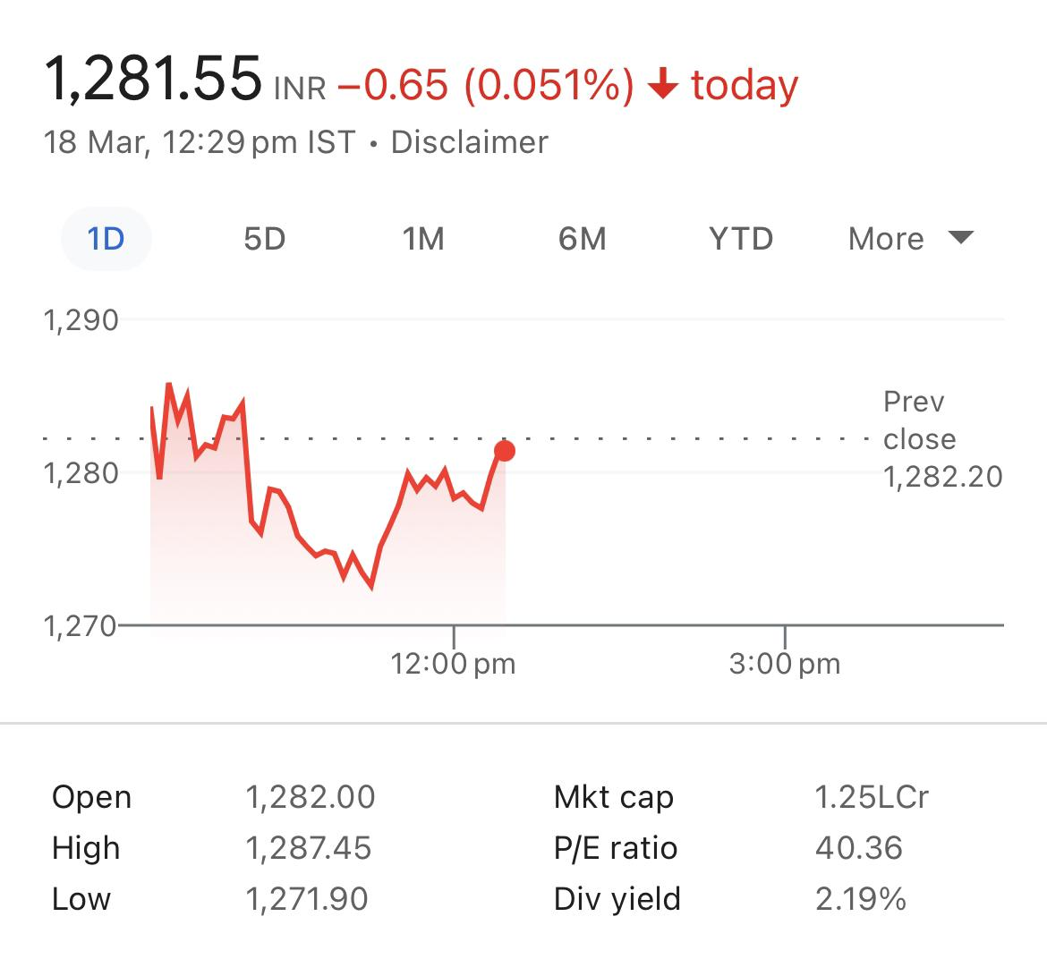

1. **Return on investment:**

As of today (2024-03-10), Tech Mahindra's weighted average cost of capital is 14.51%%. Tech Mahindra's ROIC % is 9.18% (calculated using TTM income statement data).

1. **Market share :**

As of my last update in January 2022, Market share of Tech mahindra 11.4%. Tech Mahindra is a significant player in the IT services industry, but specific market share figures can vary depending on the segment and geographic region being considered. Tech Mahindra competes with other major IT services companies such as Tata Consultancy Services (TCS), Infosys, and Wipro. To get the most accurate and up-to-date information on Tech Mahindra's market share, I recommend consulting recent industry reports or financial analyses.

* **Analysing financial performance of**

**Consumer goods service company : DABUR INDIA LTD**

1. **Revenue growth:**

Dabur India Limited ended the third quarter of 2023-24 with a 7% growth in Revenue from Operations at Rs 3,255 Crore, driven by steady performance of both the Home & Personal care and Food & Beverages businesses. Revenue stood at Rs 3,043.2 Crore in Q3 of 2022-23.

1. **Profit margin:**

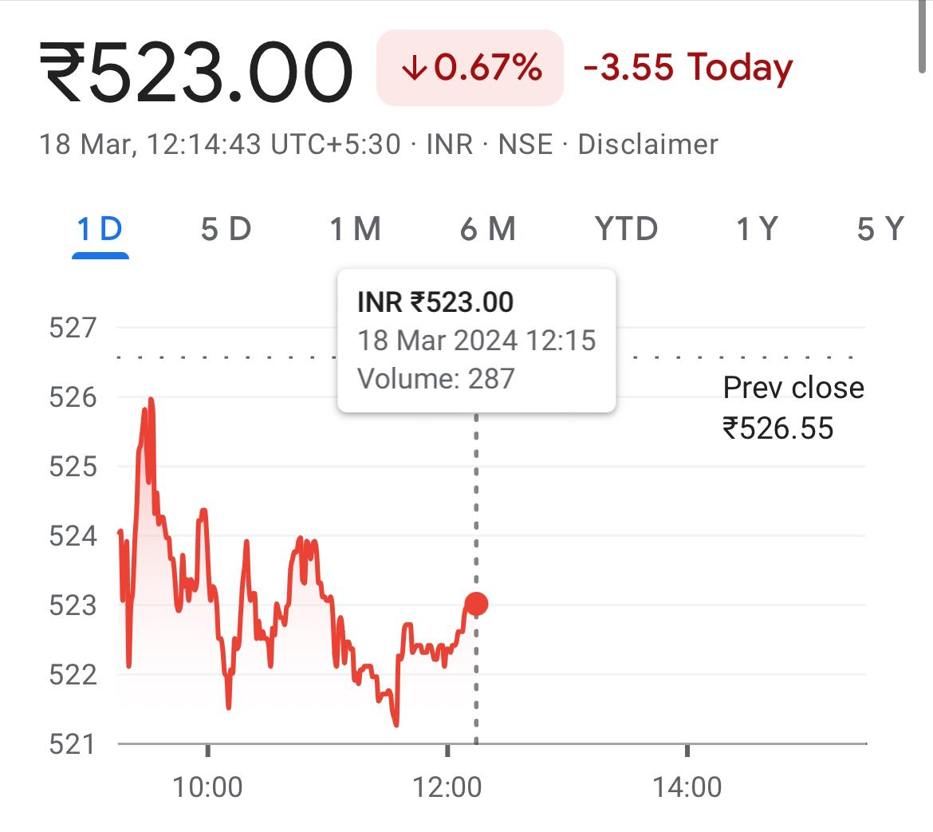

1. **Return on investment:**

ROE Ratio of Dabur India Ltd. with value of 19.61 means its generates profits efficiently by using its Shareholders Fund. ROE Ratio of DABUR has fallen by -8.32 % Compared to previous Financial Year.

1. **Market share:**

Riding on this demand, Dabur reported a strong 30% growth in sales and also reported a gain in markets share to capture 61.3% market share of J&N category in 2022-23

* **Compare competitive positions**

|  |  |  |
| --- | --- | --- |
| * **Company name** | **TECH MAHINDRA** | **DABUR INDIA LTD** |
| **Market share** | Tech Mahindra is trading 0.64% upper at Rs 1,280.25 as compared to its last closing price. Tech Mahindra has been trading in the price range of 1,285.50 & 1,270.50. Tech Mahindra has given -0.07% in this year & -3.82% in the last 5 days. | Dabur India Ltd., operating in the Personal Care sector and classified as a Largecap on the bse, currently has its share price at 522.85 The stock has experienced fluctuations today, with a low of ₹521.5 and a high of ₹526.55 Over the past 52 weeks, the shares have seen a low of ₹504 and a high of ₹596.9. |
| **Growth prospects** | Tech Mahindra's growth prospects remain strong, fueled by its focus on digital transformation services, industry expertise, and global footprint. With the accelerating demand for technology solutions worldwide, the company is poised to capitalize on emerging opportunities and sustain its upward trajectory in the digital services market | Tower India Ltd demonstrates promising growth prospects with its strategic positioning in the telecommunications infrastructure sector. As demand for network expansion and 5G deployment increases, the company is well-positioned to capitalize on opportunities, expand its market presence, and drive revenue growth in the evolving telecommunications landscape. |
| **Competitive threats** | Tech Mahindra faces competitive threats from rival IT service providers, emerging startups, and global technology firms. Rapid technological advancements, pricing pressures, and changing market dynamics pose challenges. To maintain its competitive edge, Tech Mahindra must continuously innovate, adapt to market trends, and deliver superior value to clients. | Dabur India Ltd. contends with competitive threats from both domestic and international consumer goods companies across its diverse product categories. Challenges include shifting consumer preferences, price competition, and regulatory changes. To mitigate these threats, Dabur focuses on innovation, brand building, and market expansion strategies. |
| **Barriers to entry** | Tech Mahindra faces significant entry barriers in the IT services industry due to high initial capital requirements, established competitors, and the need for specialized skills and expertise. Additionally, building a global delivery network and reputation for quality services pose challenges for new entrants seeking to compete with Tech Mahindra. | Dabur India Limited encounters notable entry barriers in the consumer goods market due to brand loyalty, extensive distribution networks, and regulatory compliance requirements. High investments in research, development, and marketing are necessary to compete effectively, posing challenges for new entrants attempting to penetrate the industry. |

* **Assessment of sustainability**

Sustainability assessment requires an evaluation of present and future conditions to show that present decisions and actions are not compromising future human and ecological health and well-being.

**Technology company: TECH MAHINDRA**

Tech Mahindra demonstrates a commitment to sustainability through various initiatives focusing on environmental conservation, social responsibility, and ethical business practices. The company has set ambitious targets to reduce its carbon footprint, minimize waste generation, and promote renewable energy usage.

Additionally, Tech Mahindra engages in community development projects, skill-building programs, and diversity and inclusion efforts. While the company's sustainability efforts are commendable, ongoing monitoring and transparent reporting are essential to ensure continued progress and accountability.

Tech Mahindra demonstrates a robust commitment to sustainability, integrating environmental, social, and governance (ESG) principles into its business practices. The company focuses on reducing its carbon footprint, promoting renewable energy, and minimizing waste generation across operations.

Tech Mahindra also engages in community development initiatives, skill-building programs, and diversity and inclusion efforts to create positive social impact. Through transparent reporting and adherence to ethical standards, Tech Mahindra aims to foster long-term sustainability while driving business growth.

However, continuous monitoring, innovation, and collaboration with stakeholders are vital to address evolving sustainability challenges and ensure a positive impact on society and the environment.

**Consumer goods sector**: **DABUR INDIA LTD**

Dabur also focuses on Sustainable Sourcing by partnering with farmers to promote organic farming practices, biodiversity conservation, and fair trade. By sourcing raw materials ethically, Dabur ensures the sustainability of its supply chain while supporting local communities.

Environmental Stewardship is another key aspect of Dabur's sustainability efforts, with a focus on reducing water consumption, energy usage, and greenhouse gas emissions. The company invests in renewable energy and waste management solutions to minimize its environmental footprint.

Community Development is integral to Dabur's sustainability strategy, with initiatives focusing on education, healthcare, and rural development. Through the Dabur Foundation, the company supports various social welfare programs and initiatives aimed at empowering marginalized communities.

Overall, Dabur India Ltd. has demonstrated a strong commitment to sustainability, incorporating ethical practices and social responsibility into its core business operations while driving positive impact across its value chain and beyond.

* **Conclusion**

1. **TECH MEHINDRA**

Tech Mahindra is a prominent player in India's technology landscape, renowned for its innovative solutions, global presence, and commitment to excellence.

The company's strategic focus on digital transformation, industry expertise, and customer-centric approach has propelled its growth and cemented its position as a leader in the IT services sector.

With a strong emphasis on sustainability, social responsibility, and ethical business practices, Tech Mahindra is well-equipped to navigate the evolving market dynamics and continue delivering value to its clients, employees, and stakeholders.

As India's digital economy continues to expand, Tech Mahindra is poised to play a pivotal role in shaping the future of technology and driving economic growth in the country.

1. **DABAR INDIA LIMITED**

Dabur India Ltd. stands as a beacon of trust and innovation in India's consumer goods industry, with a rich heritage dating back to 1884. The company's unwavering commitment to Ayurveda, natural ingredients, and wellness has solidified its position as a trusted household name.

Dabur's diverse product portfolio, encompassing personal care, healthcare, and home care segments, caters to a wide range of consumer needs, reflecting its adaptability and market responsiveness.

Through sustainable sourcing practices, environmental stewardship, and community development initiatives, Dabur demonstrates its dedication to social responsibility and ethical business conduct. As India's consumer market continues to evolve, Dabur's focus on innovation, quality, and consumer satisfaction positions it strongly for sustained growth and continued leadership in the years ahead.

***

**Name : M. Satish**

**College : DR. Lankapalli Bullayya College**